 | American International University- Bangladesh (AIUB)  Faculty of Engineering (FE)
Course Name : |  | Digital Logic & Circuits Laboratory |  |  |  |  | Course Code : |  | EEE 1204
Semester : |  | Summer 2023-24 |  |  |  |  | Sec : |  | G
Lab Instructor : |  | MD. ALOMGIR KABIR |  |  |  |  | Group : |  | 07
Experiment No : |  | 01
Experiment Name : |  | Studying different digital logic gates and designing of basic logic gates using Universal gates
Submitted by (NAME): |  | Chinmoy Guha |  |  |  | Student ID: |  |  | 22-48056-2
Group Members |  |  |  |  | ID |  |  | Name
 |  |  |  | 1. | 22-48056-2 |  |  | CHINMOY GUHA
 |  |  |  | 2. | 22-48067-2 |  |  | SUVRA CHAKRABORTY
 |  |  |  | 3. | 22-47975-2 |  |  | MOHAMMAD ANSAR UDDIN
 |  |  |  | 4. | 22-49385-3 |  |  | NAZMUL HASSAN NAYEEM
 |  |  |  | 5. | 22-49393-3 |  |  | EFAZ MASHRUR AMIN
 |  |  |  | 6.
 |  |  |  | 7.
Performance Date : |  |  | 23/10/24 |  |  | Due Date : |  |  |  | 30/10/24
Marking Rubrics (to be filled by Lab Instructor)
Category | Proficient  [6] | Good  [4] | Acceptable  [2] | Unacceptable [1] | Secured Marks
Theoretical Background, Methods  & procedures sections | All information, measures and variables are provided and explained. | All Information provided that is sufficient, but more explanation is needed. | Most information correct, but some information may be missing or inaccurate. | Much information missing and/or inaccurate.
Results | All of the criteria are met; results are described clearly and accurately; | Most criteria are met, but there may be some lack of clarity and/or incorrect information. | Experimental results don’t match exactly with the theoretical values and/or analysis is unclear. | Experimental results are missing or incorrect;
Discussion | Demonstrates thorough and sophisticated understanding. Conclusions drawn are appropriate for analyses; | Hypotheses are clearly stated, but some concluding statements not supported by data or data not well integrated. | Some hypotheses missing or misstated; conclusions not supported by data. | Conclusions don’t match hypotheses, not supported by data; no integration of data from different sources.
General formatting | Title page, placement of figures and figure captions, and other formatting issues all correct. | Minor errors in formatting. | Major errors and/or missing information. | Not proper style in text.
Writing & organization | Writing is strong and easy to understand; ideas are fully elaborated and connected; effective transitions between sentences; no typographic, spelling, or grammatical errors. | Writing is clear and easy to understand; ideas are connected; effective transitions between sentences; minor typographic, spelling, or grammatical errors. | Most of the required criteria are met, but some lack of clarity, typographic, spelling, or grammatical errors are present. | Very unclear, many errors.
Comments: |  |  |  | Total Marks  (Out of ):

Abstract:
To learn the characteristics of several logic gates and to get familiar with the digital trainer board and digital ICs.

Part I (Basic Logic IC’s):
An integrated circuit (also referred to as an IC, a chip, or a microchip) is a set of electronic circuits on one small plate ("chip") of semiconductor material, normally silicon. This can be made much smaller than a discrete circuit made from independent components. Different integrated circuits are used to implement different logical operations in the trainer board which will be introduced in this experiment.

Theory and Methodology:

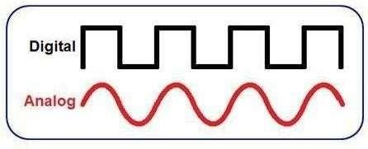
In analog signaling, information is conveyed through electric pulses with varying amplitudes, while digital signaling encodes data as binary numbers (0s and 1s), with each bit corresponding to a specific, distinct voltage level.

The primary benefit of digital signals over analog signals is their resilience against imperfections in electronic systems, which often interfere with analog signals. Codes are commonly employed in information transmission, either to secure the data or to break it into manageable parts for the transmission technology. Digital signals offer greater immunity to noise since each data element (such as a byte) is defined by the presence or absence of a binary bit. Unlike analog signals that continuously vary and are highly susceptible to noise, digital signals can be efficiently processed by inexpensive digital circuits, often integrated into a single chip. Digital systems also typically consume less bandwidth and produce lower electromagnetic interference, and their noise immunity enables reliable data storage and retrieval.

In digital systems, circuits are generally divided into two types: integrated circuits (ICs) and discrete circuits. Integrated circuits offer notable advantages over discrete circuits in both cost and performance. Their cost is low due to the manufacturing method—photolithography—which produces the entire chip, including all its components, at once rather than assembling individual transistors. Less material is required for a single IC chip than for an equivalent discrete circuit, and the small, closely packed components in an IC allow for faster switching and lower power consumption.

A fundamental element of digital circuits is the logic gate. Most logic gates operate with two inputs and produce one output, with each terminal existing in a binary state: either low (around 0 volts) or high (around 5 volts). As the circuit processes data, these logic states change frequently. In most cases, the low state is close to zero volts, while the high state is around +5 volts, distinguishing the binary conditions within the circuit.

There are seven basic logic gates: AND, OR, NOT, NOR, NAND, XOR and XNOR.
Different logic operations of different IC’s will be introduced which perform the following characteristics:
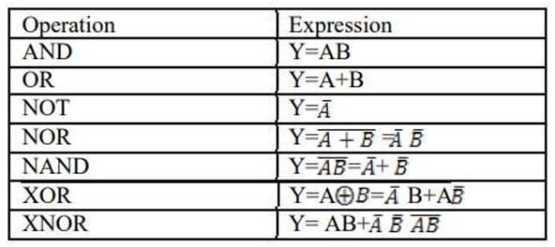

AND operation:
The AND operation produces a high if and only if all the inputs are high. An AND gate can have two or more inputs and performs AND operation or logical multiplication.
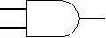
Fig1.1: Symbol of AND gate

Input, A | Input, B | Output, F
0 | 0 | 0
0 | 1 | 0
1 | 0 | 0
1 | 1 | 1

Pin configuration for IC-74HC08N:
For a quadrature 2input AND gate HC08 device code is used. 74HC series devices are designed to work with a 5 V power supply, voltages from 2 V to 5 V are allowed and most circuits work well using 5 V.

OR operation:
The OR operation produces a high output when any of the inputs are high. It has two or more inputs and one output which performs OR operation or logical addition.
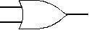

Fig 1.2: Symbol of OR gate Truth Table:
Input, A | Input, B | Output, F
0 | 0 | 0
0 | 1 | 1
1 | 0 | 1
1 | 1 | 1

Pin configuration for IC-74HC32N:

HC32 is the device code. 74HC32 is a Quad 2-input OR gate (High Speed CMOS version) which has lower current consumption/wider Voltage range from 2 to 5V. It requires low input current of 1μA with high noise immunity characteristics of CMOS devices.

NOT operation:
The NOT operation changes one logic level to the opposite logic level. It is implemented by a logic circuit known as an invert

Input, A | Output, F
0 | 1
1 | 0

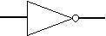

Fig1.3: Symbol of NOT gate

Truth Table:

Pin configuration for IC-74HC04N:

The 74HC04 is a hex inverter which consists of six inverters which perform logical invert action. The inputs include clamp diodes that enable the use of current limiting resistors to interface inputs to voltages in excess of V_{CC}. The Input level for 74HC04 is CMOS level.

NAND operation:

The NAND gate operates as an AND gate followed by a NOT gate. It acts in the manner of the logical operation "AND" followed by negation. The output will be low if both inputs are high. Otherwise, the output is high.

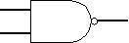

Fig 1.4: Symbol of NAND gate Truth Table:

Input, A | Input, B | Output, F
0 | 0 | 1
0 | 1 | 1
1 | 0 | 1
1 | 1 | 0

Pin configuration for IC-74HC00N :
HC00 is the device code. The device inputs are compatible with Standard CMOS outputs; with pullup resistors. The operating voltage range is 2.0 to 5.0 V and low input current is 1.0 µA.

NOR operation:

The NOR gate is a combination OR gate followed by an inverter. Its output is high if both inputs are low. Otherwise, the output is low.
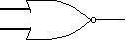

Fig 1.5: Symbol of NOR gate

Truth Table:

Input, A | Input, B | Output, F
0 | 0 | 1
0 | 1 | 0
1 | 0 | 0
1 | 1 | 0

Pin configuration for IC-74HC02N:

The 74HC02 is a high-speed Si-gate CMOS device that provides a quadrature 2 –input NOR function. CMOS level is the input level for this sort of IC’s. The operating Voltage Range is 2.0 to 5.0 V and low input current is 1.0 µA.

XOR operation:

The XOR (exclusive OR) gate acts in the same way as the logical "either/or”. The output is high if either, but not both, of the inputs are high. The output is low if both inputs are low or if both inputs are high.
Another way of looking at this circuit is to observe that the output is 1 if the inputs are different, but 0 if the inputs are the same.

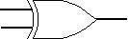

Fig 1.6: Symbol of XOR gate Truth Table:
Input, A | Input, B | Output, F
0 | 0 | 0
0 | 1 | 1
1 | 0 | 1
1 | 1 | 0

Pin configuration for IC-74HC86N :
HC86 is the device code for a quad 2-input xor gate which utilizes advanced silicon gate CMOS technology . It maintains low power consumption and high noise immunity characteristic of standard CMOS integrated circuits. The 74HC logic family has a voltage range of 2V to 5V and the operating temperature is -40°C to 125°C with input current of 1µA.

XNOR operation:

The XNOR (exclusive-NOR) gate is a combination XOR gate followed by an inverter. Its output is high if the inputs are the same, and low if the inputs are different.

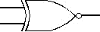
Fig 1.7: Symbol of XNOR gate

Truth Table:

Input, A | Input, B | Output, F
0 | 0 | 1
0 | 1 | 0
1 | 0 | 0
1 | 1 | 1

Using combinations of logic gates, complex operations can be performed. Arrays of logic gates are found in digital integrated circuits (ICs). As IC technology advances, the required physical volume for each individual logic gate decreases and digital devices of the same or smaller size become capable of performing ever more complicated operations at ever- increasing speeds.

Apparatus:

- Digital trainer board.
- Integrated Circuits (ICs).
- Power supply.
- Connecting wires.

Integrated Circuits (ICs):
7400: 1 pcs
7402: 1 pcs
7404: 1 pcs
7408: 1 pcs
7432: 1 pcs
7486: 1 pcs

Lab work:
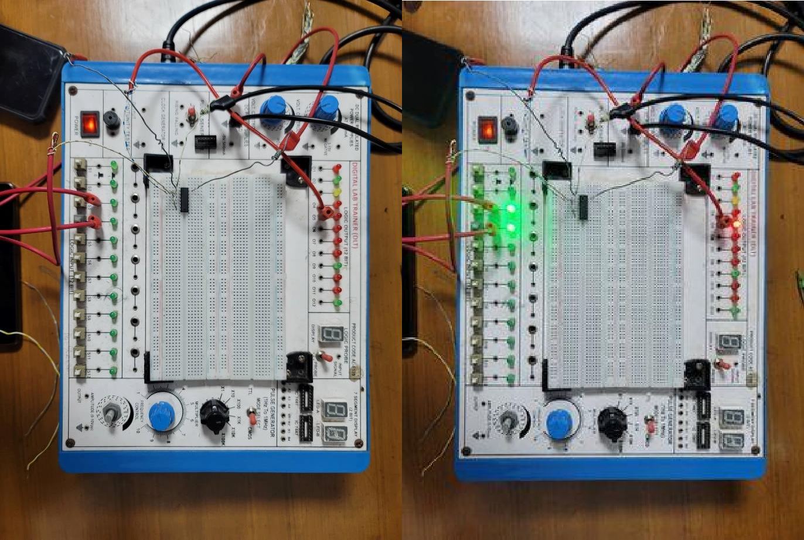
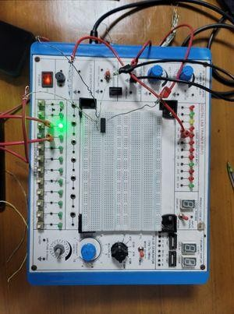
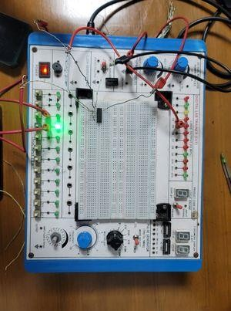

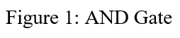
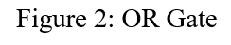
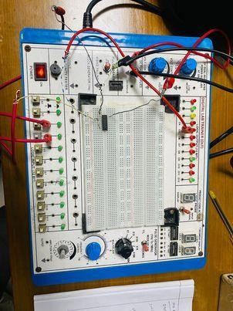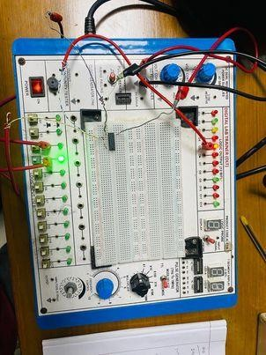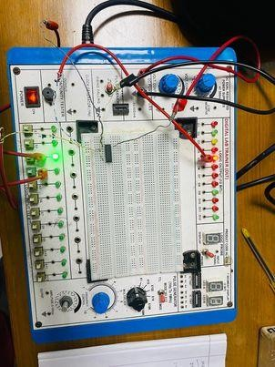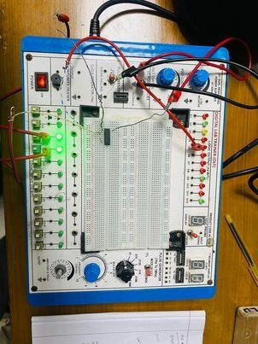

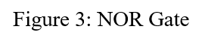
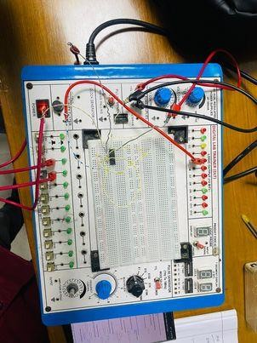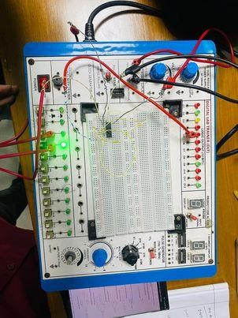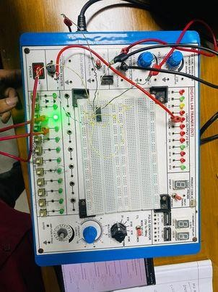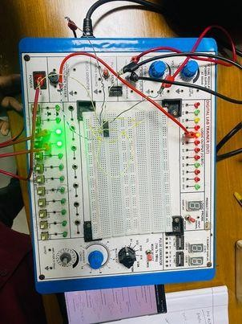

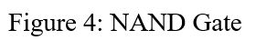
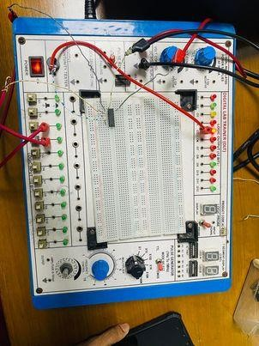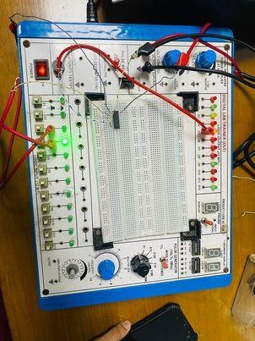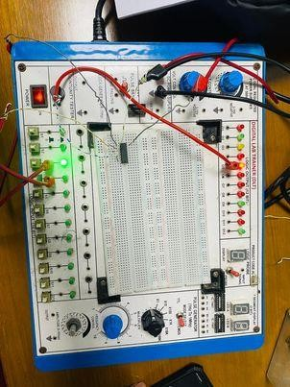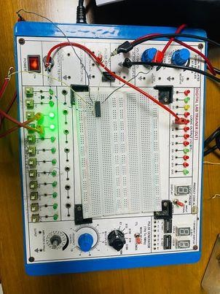

Simulations: AND gate

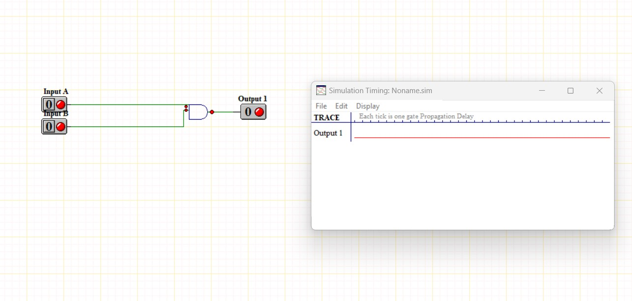

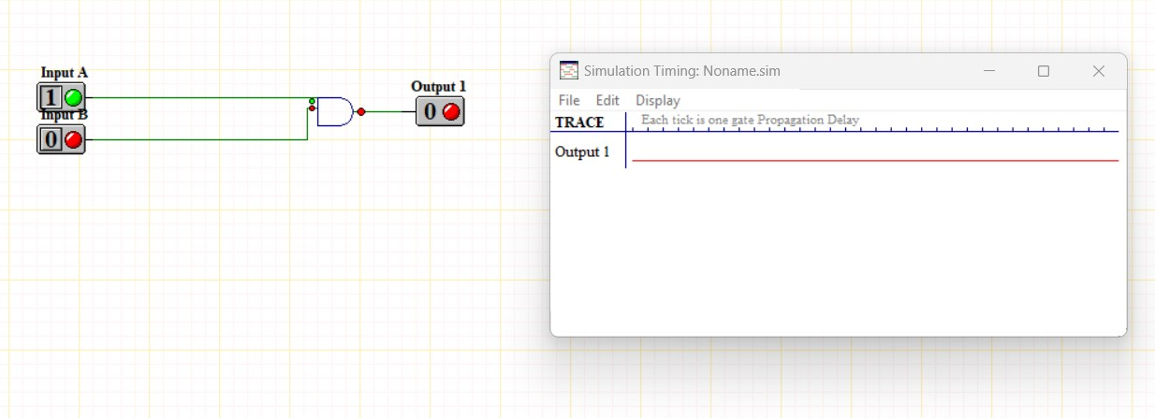

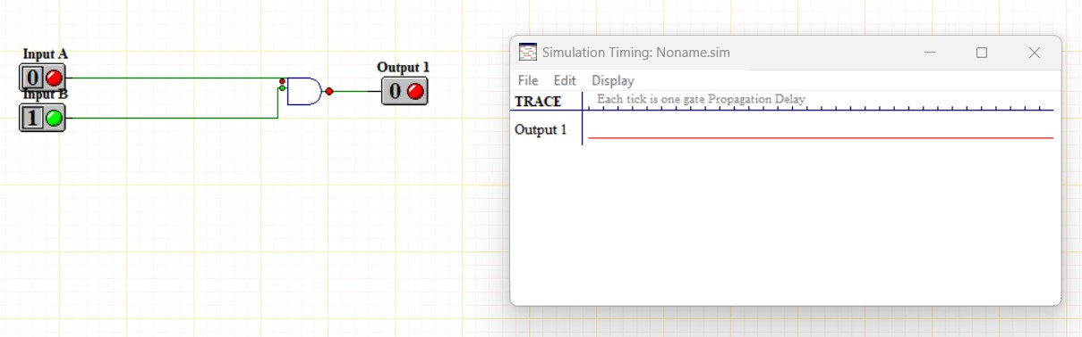
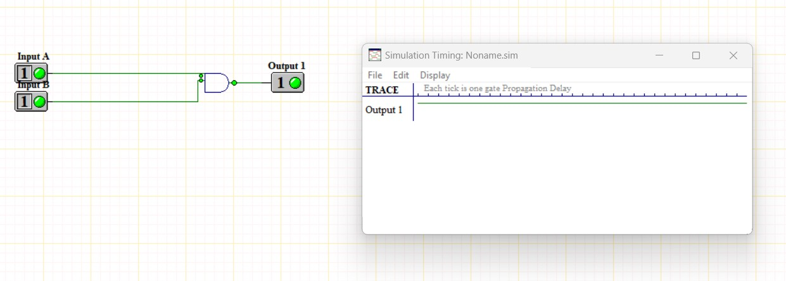

OR gate
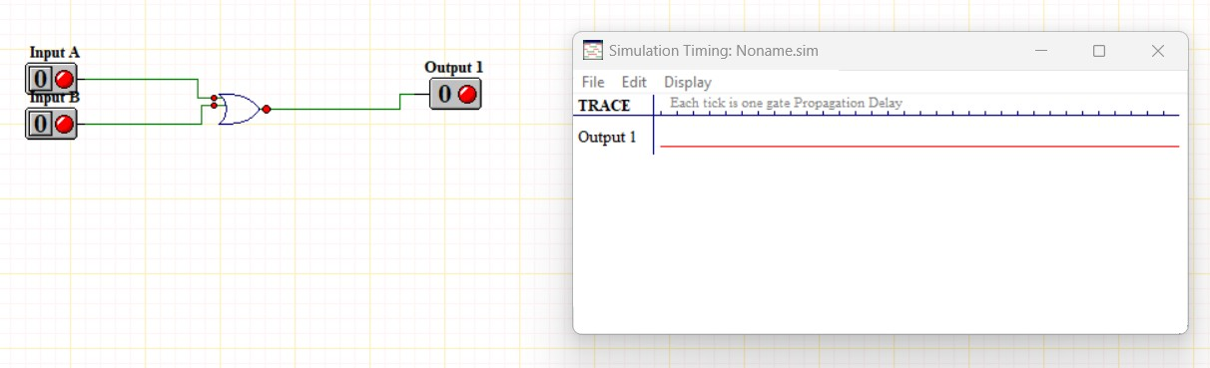

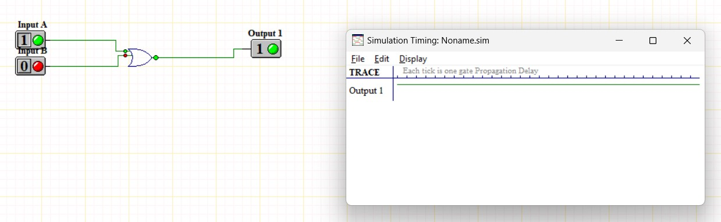
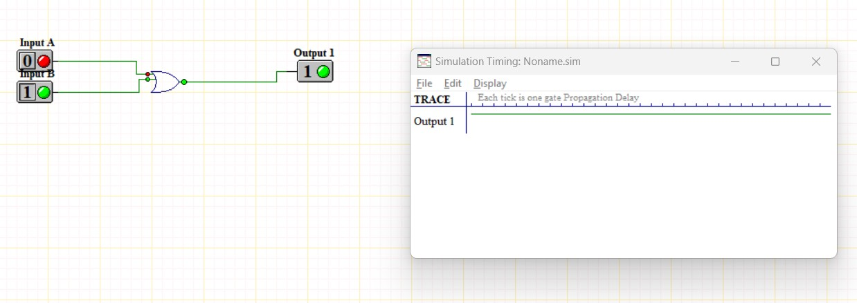
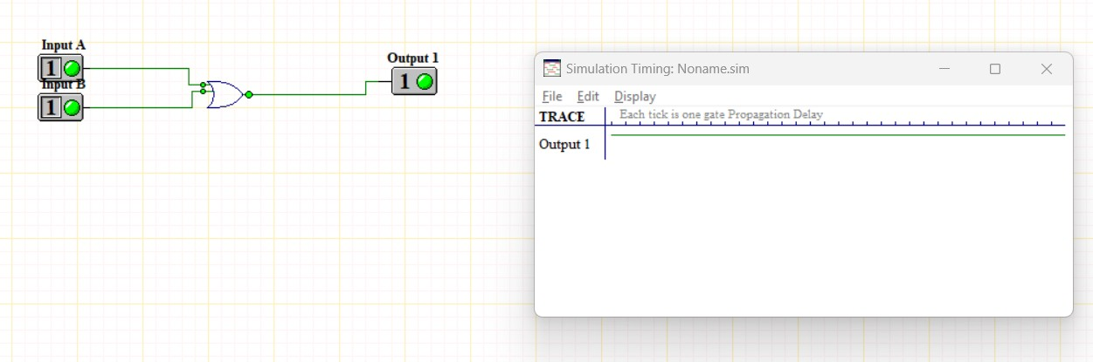

Not gate

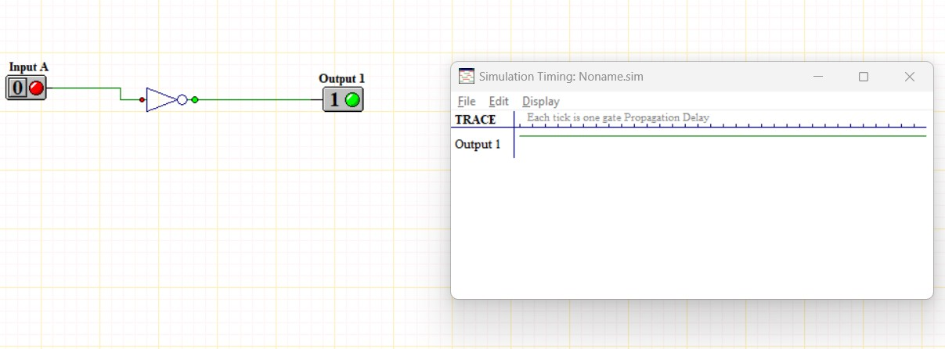
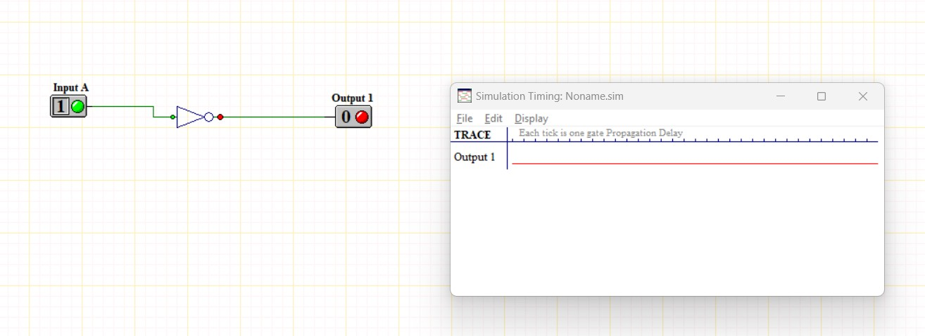

Nand gate using basic gate
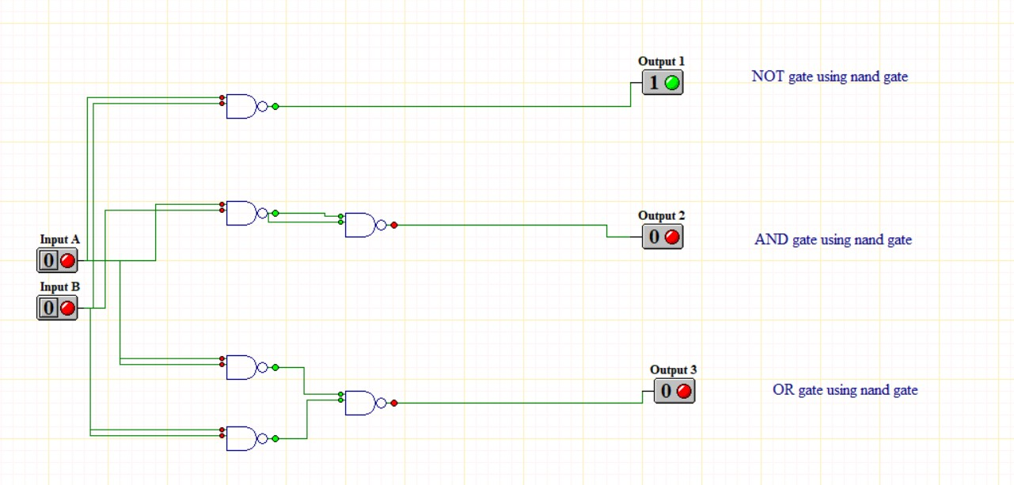

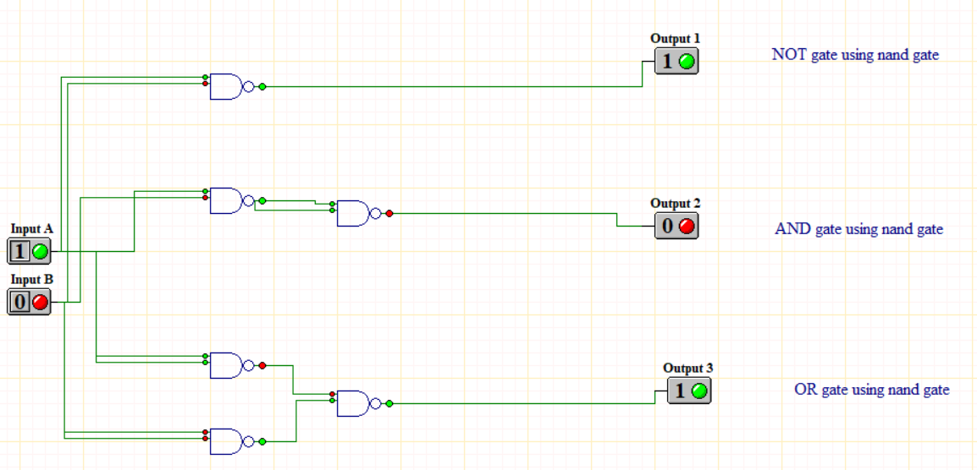
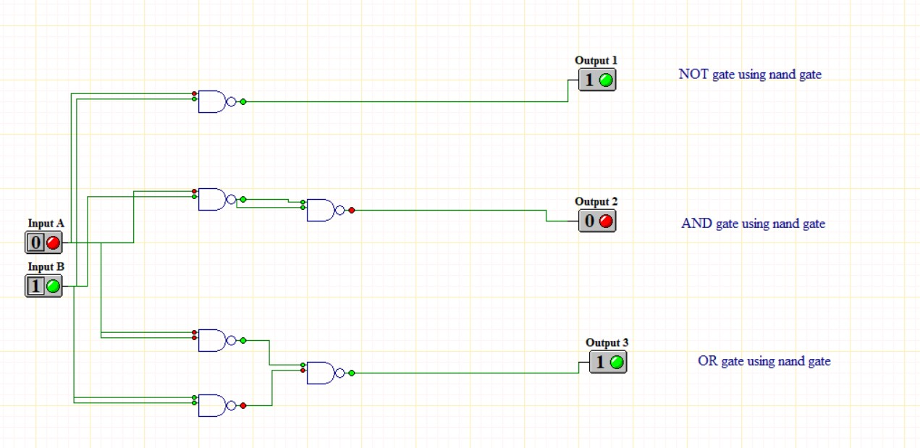

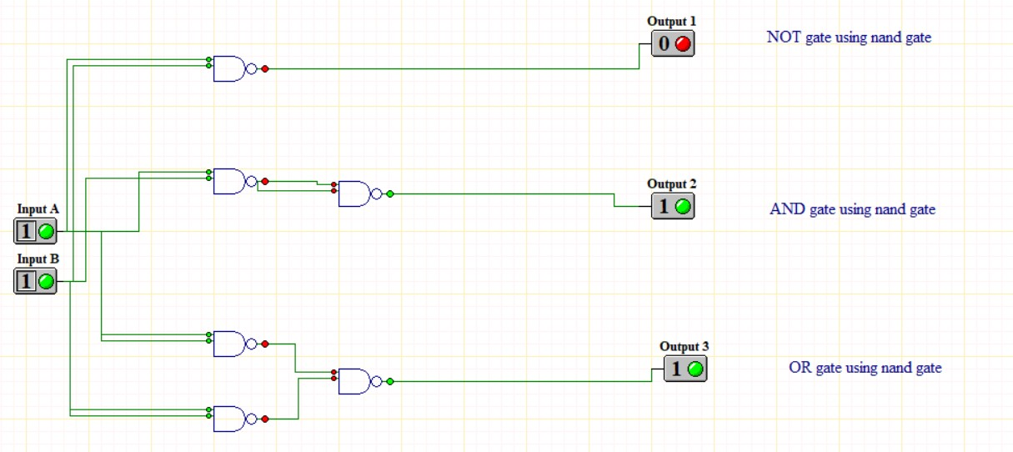

Basic gate using NOR gate
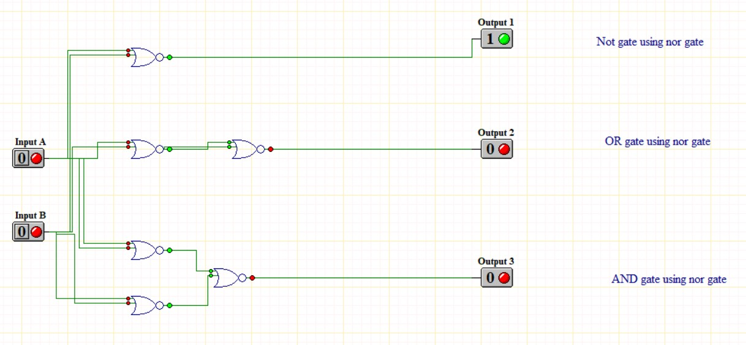

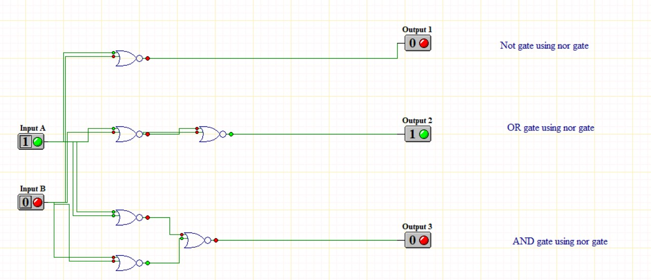
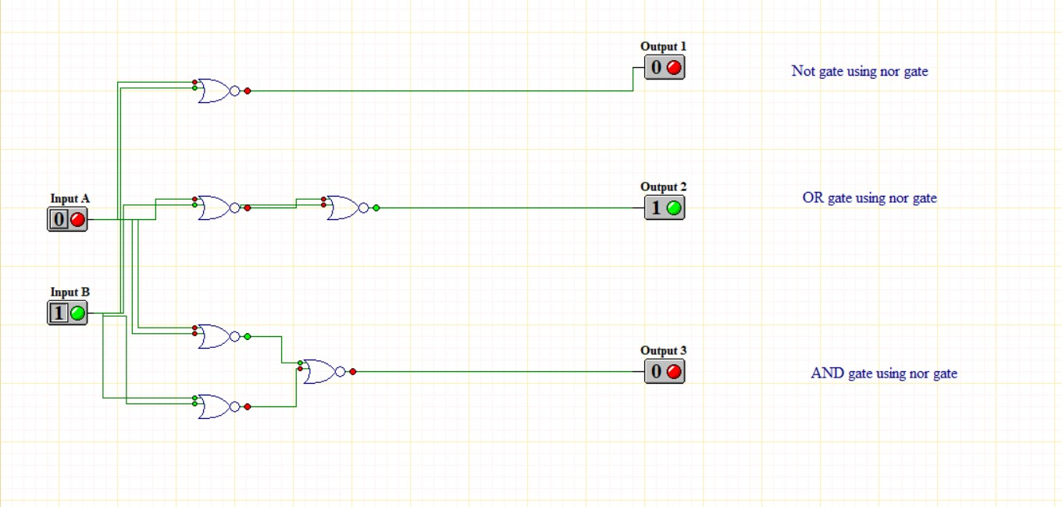

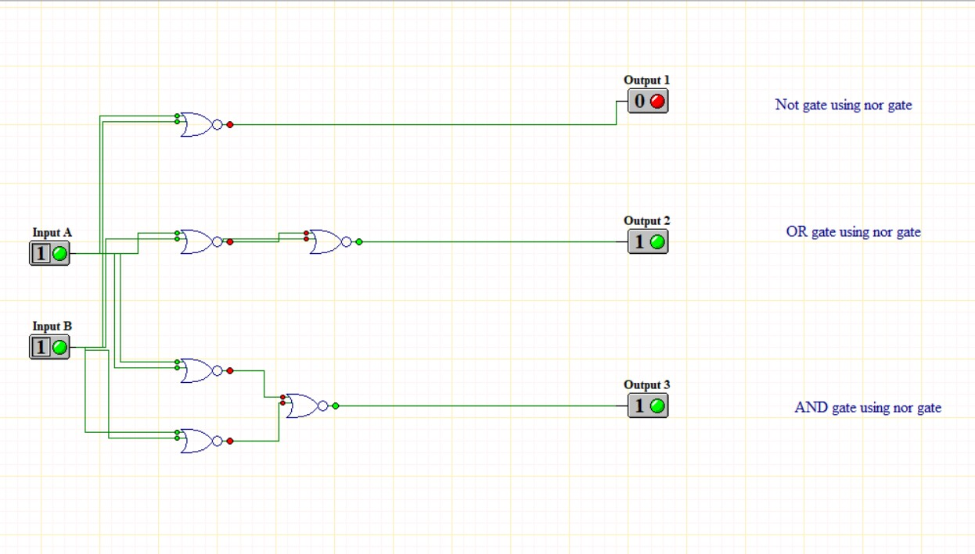

QUESTIONS ANSWER :

- What do you mean by universal gate?
Ans: A universal gate is a type of logic gate that can be used to implement any Boolean function without needing to use any other type of gate. The two most common universal gates are NAND and NOR gates.
NAND Gate: A logic gate that outputs false only when all its inputs are true. In all other cases, it outputs true. By combining NAND gates in various ways, you can create the other basic logic gates (AND, OR, NOT) and thus implement any Boolean function.
NOR Gate: A logic gate that outputs true only when all its inputs are false. Like the NAND gate, NOR gates can be combined to create the other basic logic gates.
Because of their versatility, universal gates are fundamental in digital circuit design.
- What are the ICs required in this experiment?
Ans: Integrated circuits, or ICs, are needed to perform various logical operations. Various integrated circuits including 7400: 1 PC, 7402: 1 PC, 7404: 1 PC, 7408: 1 PC, 7432: 1 PC, and 7486: 1 PC were used to implement the aforementioned circuits in this experiment.
- Construct a circuit of output F, where F=AB + BC + CA, by using NAND gates only in the NI-Multisim Software and show the output states for each of the available conditions.
Ans: Here is three input A, B and C and the output is F.

Expressions:
F= AB + BC + CA

Circuit Diagram:
Table 18: Truth Table:
A | B | C | F
0 | 0 | 0 | 0
0 | 0 | 1 | 0
0 | 1 | 0 | 0
0 | 1 | 1 | 1
1 | 0 | 0 | 0
1 | 0 | 1 | 1
1 | 1 | 0 | 1
1 | 1 | 1 | 1

Figure 5: Simulation using NAND gate.

Table 19: The output state is shown for each available state:
A B C F  0 0 0 0 |  | A B C F  0 0 1 0
A B C F  0 1 0 0 |  | A B C F  0 1 1 1
A B C F  1 0 0 0 | A B C F  1 0 1 1
A B C F  1 1 0 1 | A B C F  1 1 1 1

Discussion and Conclusion:

In the experiment, circuits were built using ICs which contain different logic gates. All the pins and ICs were connected properly. Then different combination of input was provided using switches and the output of the circuits was observed and compared with the corresponding truth table, circuits were also simulated using
Ni-Multisim.
The output from the circuits was found to be similar to their corresponding truth table and also same results were obtained using simulation. So, the working logic of the gates was verified and the experiment was successful.

Reference(s):
- www.tutorialspoint.com
- www.electronics-tutorials.ws
- faculty.kfupm.edu.sa
- “Digital Fundamentals” by Thomas L. Floyd

